Hancock County Food Pantry New Client Registration Form
Drive thru pantry – clients stay in their vehicles at all times

Please fill out all the information below on this form before you get to the check-in desk. Please print carefully
The TOTAL GROSS INCOME of your entire household must be LESS than the amounts listed below (based on your household size) to qualify as a client.

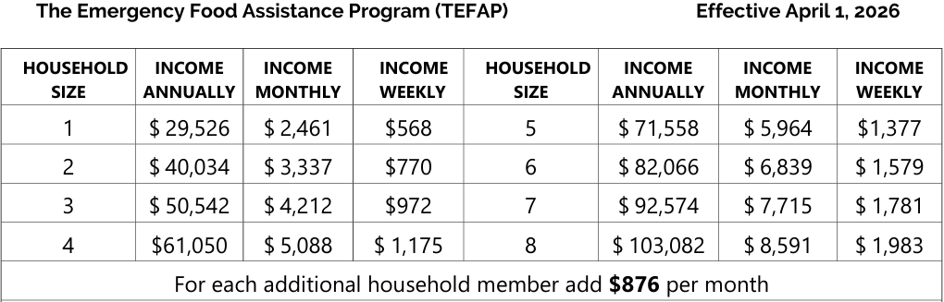
*****************************************************************************
HEAD OF HOUSEHOLD:
FIRST NAME: _________________________________
MIDDLE NAME: ________________________________

LAST NAME: ________________________________________________
Total Number of People Living in Your Household: ________________________________
YOUR CITY: ______________________________________________________________

YOUR STATE: ___________________

YOUR ZIP CODE: _____________________________________
YOUR COUNTY: ____________________________________________________
OPTIONAL INFO BELOW – NOT REQUIRED TO RECEIVE FOOD)

Phone Number: _________________________________ (this will allow us to contact you w/closure info)
Number of people in the following age ranges living in your home:
_____ # 0-5 _____ #6-17 _____#18-54 _____#55-59 _____#60-64 _____#65+
Number of Veterans in your home: ________ form updated 4/7/26

