Hancock County Food Pantry New Client Registration Form

Please fill out all the information below on this form before you get to the check-in desk. Please print carefully

The TOTAL GROSS INCOME of your entire household must be LESS than the amounts listed below (based on your household size) to qualify as a client.

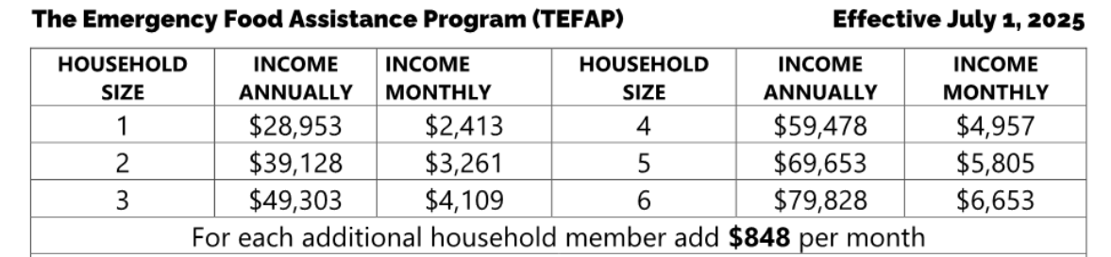

*****************************************************************************

HEAD OF HOUSEHOLD:  
FIRST NAME: _________________________________________

MIDDLE NAME: _______________________________________

LAST NAME: ______________________________________________

Total Number of People Living in Your Household: _______________________

YOUR CITY: ______________________________________________________________

YOUR STATE: ___________________

YOUR ZIP CODE: _____________________________________

YOUR COUNTY: ________________________________________

OPTIONAL INFO BELOW – NOT REQUIRED TO RECEIVE FOOD)

Number of people in the following age ranges living in your home:

_____ # 0-5 _____ #6-17 _____#18-54 _____#55-59 _____#60-64 _____#65+

Number of Veterans in your home: ________ form updated 5/25